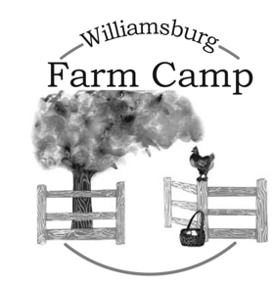
Williamsburg Farm Camp
Summer 2024 Registration

Camper Information

Camper Last Name: __________________________ First Name: ____________________________

Boy ____ Girl ____ Date of Birth ___/___/___ Age at Camp: ______

Family e-mail: ________________________________

Camper’s Address: ___________________________________

City: ______________________ State:___________ Zip: ________

Parent/Guardian Information

Last Name: _____________________________ First Name:____________________________

Relationship to Camper:___________________

Phone Number: ________________________________(indicate cell or land line)

Alternative Phone Number: ________________________

Who besides the parent/guardian is authorized to pick this camper up?

How did you hear about Williamsburg Farm Camp?

Emergency Contact
(If the Parent/Guardian cannot be reached, please contact the person listed below.)

Name: __________________________________________Relationship: _________________________

Phone Number: ________________________Alternative Phone Number: _________________________

Photo Release
___I give permission for photos of my camper to be used in the promotion of the Williamsburg Farm Camp.

___I do not give permission for photos of this camper to be used in the promotion of the Williamsburg Farm Camp.

Williamsburg Farm Camp 2024

Camp Sessions
Which session(s) would you like to attend?

______June 17 - June 21 ______June 24 - June 28 ______July 8 - July 12 _____July 15 - July 19

Camp tuition: $400/camper/week
$375/week sibling or multiple week rate

To reserve your space, a $175 non-refundable deposit is due with this registration form.
The remaining balance is due by June 1, 2023.
Expect more information as Farm Camp gets close.

Did you know that Farm Camp may be tax deductible for you? Ask us how!

Make checks payable to Hideaway Farm.
Mailing address: PO Box #54, Norge, Va. 23127

Cancellation and Refund
We will have camp rain or shine. If a camper needs to withdraw for medical reasons, a physician’s documented medical reason will enable the camper to receive a refund for the portion of the session not attended.

I have provided camper, parent/guardian, and emergency contact information; I understand the photo release statement; and I agree to the camp tuition, deposit and related terms.

Authorized Signature _____________________________________________________

Welcome!
We look forward to having the privilege of working with your camper.

Life is always an adventure on the Farm!

WilliamsburgFarmCamp.com – 757-817-7336
Want to know more about our new full-program farm school? Visit
WilliamsburgFieldSchool.com

